**Product (1)**

**Bidet control panel**

(small piece that could be installed underneath of existing toilet seat)

Illustrative Image

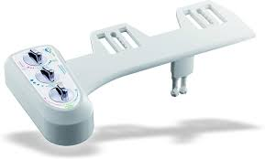

**Technical Requirements (functions):**

1. **Non-Electric - For simple installation.**
2. **Dual nozzles allowing user to choose feminine or posterior wash and make sure the spray nozzles are soft and non-harmful.**
3. **Water temperature/pressure control knobs.**
4. **Built-in cold-water bypass.**
5. **Continuous supply of warm water.**
6. **Self-cleaning spray nozzle.**
7. **Braided stainless steel water supply lines for both hot & cold water.**
8. **Polished metal T adapters.**
9. **Brass internal flow valve and stem.**
10. **ABS resin material to prevent breakage.**
11. **Unified ABS valve for better regulated water stream - new ABS unified valve system instead of valve with tubing for better durability.**
12. **Removable nozzle for better hygiene - nozzle can be easily replaced by user just by sliding it out of brackets for better personal hygiene.**
13. **Splash Guarded Nozzle - splash guard is added to nozzle.**
14. **P.S.P.C (Positive Stepping Pressure Control) - pressure control with variable stepping knob. Stepping control knob allows easier pressure control.**
15. **Double sided body panel - Bottom body panel is added to better protect tubing from ware and tare and easy cleaning.**

**Product (2)**

**Smart Bidet control panel with toilet seat**

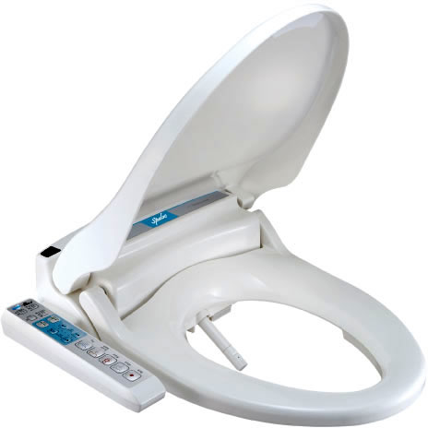

**Technical Requirements (functions):**

1. **Ergonomic design: state-of-The- design.**
2. **Posterior: satisfying water stream.**
3. **Dual nozzles allowing user to choose feminine or posterior wash and make sure the spray nozzles are soft and non-harmful.**
4. **Oscillating: Manuel wide clean.**
5. **Nozzle adjustment: manually adjust nozzle position.**
6. **Warm water: temperature can be adjusted in 4 levels.**
7. **Compatibility: designed to fit all 2-piece toilets.**
8. **Digital sensor: capacitance seat sensor.**
9. **Large water tank: continues warm water supply up to 45 continues seconds.**
10. **Heated seat: temperature controlled warm seat.**
11. **Air pump: built-in air pump for softer and satisfying cleaning.**
12. **Hydraulic seat/lid: soft close seat and lid with specially designed dampers.**
13. **Aerated water: soft air bubble added water stream.**
14. **Anterior: soft mist water stream.**
15. **Oscillating: auto wide clean.**
16. **Self clean: hygienic auto self clean.**
17. **Pulsating: pulsated massage action to stimulate rectum to help bowel movement.**
18. **Pressure control: water pressure can be adjusted in 4 levels.**
19. **Ultra- sonic weld: tightest seal with special ultrasonic welding technology.**
20. **Built-in filters: built-in external water filter as standard.**
21. **Warm air dry: temperature controlled warm air dry.**
22. **Built-in regulator: built-in PCB regulator.**
23. **Power saving: smart power saving mode and manual mode.**
24. **Catch plate: catch plate type installation allows quick release for easier cleaning.**
25. **battery charger 220V.**

**Product (3)**

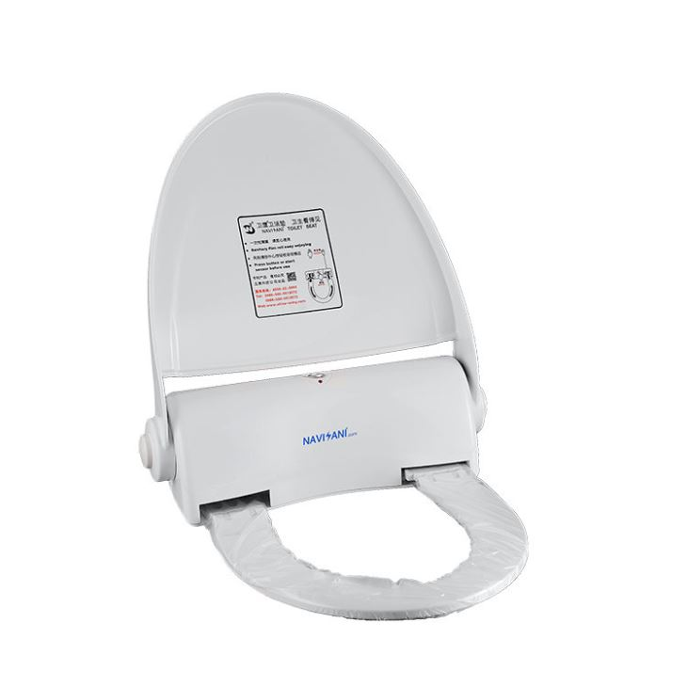

**Technical Requirements (functions):**

1. **battery charger 220V.**

**General specification for all product**

1. **ABS resin material to prevent breakage.**
2. **Our company logo on the product.**
3. **Instruction in Arabic and English.**
4. **We want you to put this mark on the box (Made in China for Saudi Quality).**
5. **All the products need to meet the Saudian standardization, Metrology and Quality (SASO).**